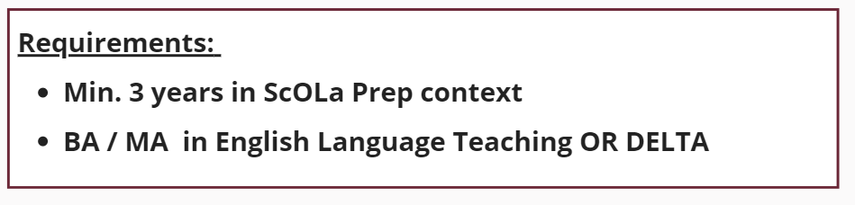

Name & Last Name:
Please briefly ...
1.summarise your “relevant education / training” with reference to the role
2.summarise your “relevant experience” with reference to the role

3.provide a basic description of your aspirations and possible contributions to ScOLa TLDU & your motivation for the role

4.state what kind of challenges and rewards you expect from this role

