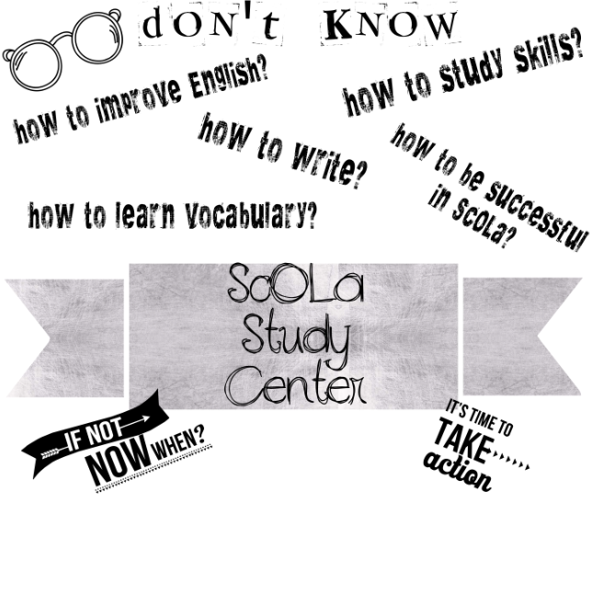

***We are here to HELP!***

***Visit us whenever you need help in studying English.***

**Timetable**

|  |  |  |  |  |  |  |  |
| --- | --- | --- | --- | --- | --- | --- | --- |
| DAYS | MONDAY | TUESDAY | WEDNESDAY | | THURSDAY | | FRIDAY |
| Hours | 13.45-15.35 | 13.45-15.35 | 13.45-16.35 | 13.45-16.35 | | 13.45-15.35 | |
| Check availability  &  Book a slot | **Esra Çelik Soydan:** <https://calendly.com/esra-celik/studycenter> | | **Özlem Kaplan:**  <https://calendly.com/ozlem-kaplan/study-center> | | | **Esra Çelik Soydan:** <https://calendly.com/esra-celik/studycenter> | |

|  |  |  |  |  |
| --- | --- | --- | --- | --- |
|  | MONDAY | TUESDAY | WEDNESDAY | THURSDAY |
| Speaking Practice Slots | 13.45-16.35 | 13.45-15.35 | 13.45-16.35 | 13.45-15.35 |
| Check availability  &  Book a slot | Send an e-mail to: james.carney@ozyegin.edu.tr | | | |

cid:image007.jpg@01CF2643.B7A7B740

**2019-2020 Academic Year – Summer Semester**